**CS 203 - Software Tools and Techniques for AI**

Assignment 8

Jatin Agarwal (23110147) ,Anuj Manoj Joshi (23110033)

Github : <https://github.com/Jatinagarwal24/CS_203_Assignment_8>

Fastapi-1 - <https://hub.docker.com/repository/docker/jatinagrwal12/fast-api-1/general>

Fastapi-2 -<https://hub.docker.com/repository/docker/jatinagrwal12/fastapi2/general>

Elastic Search - <https://hub.docker.com/repository/docker/jatinagrwal12/elasticsearch/general>

Google Drive Links:

Fastapi:1=<https://drive.google.com/file/d/1-WTCj6FOJ3uL1LGMtgi-0tJhRfjvrP5e/view?usp=sharing>

Fastapi:2=<https://drive.google.com/file/d/1iT9V6GYm0cTnZaKlk1fJKMFP3ILlS5YM/view?usp=sharing>

Elastic Search =<https://drive.google.com/file/d/16QkW491lRG0DvYWxQss3muxYZGRWyh6g/view?usp=sharing>

Creating Instance (cost optimized):

* Change the region to Montreal.
* In the OS and storage, change the OS to Ubuntu and Version to 24.04 LTS x86_64 amd64

, and storage size to 30 GB.

* In Networkings, allow the http and https traffic on the network
* In advance, change the Provisioning Model, change Standard to spot.

Creating firewall rule:

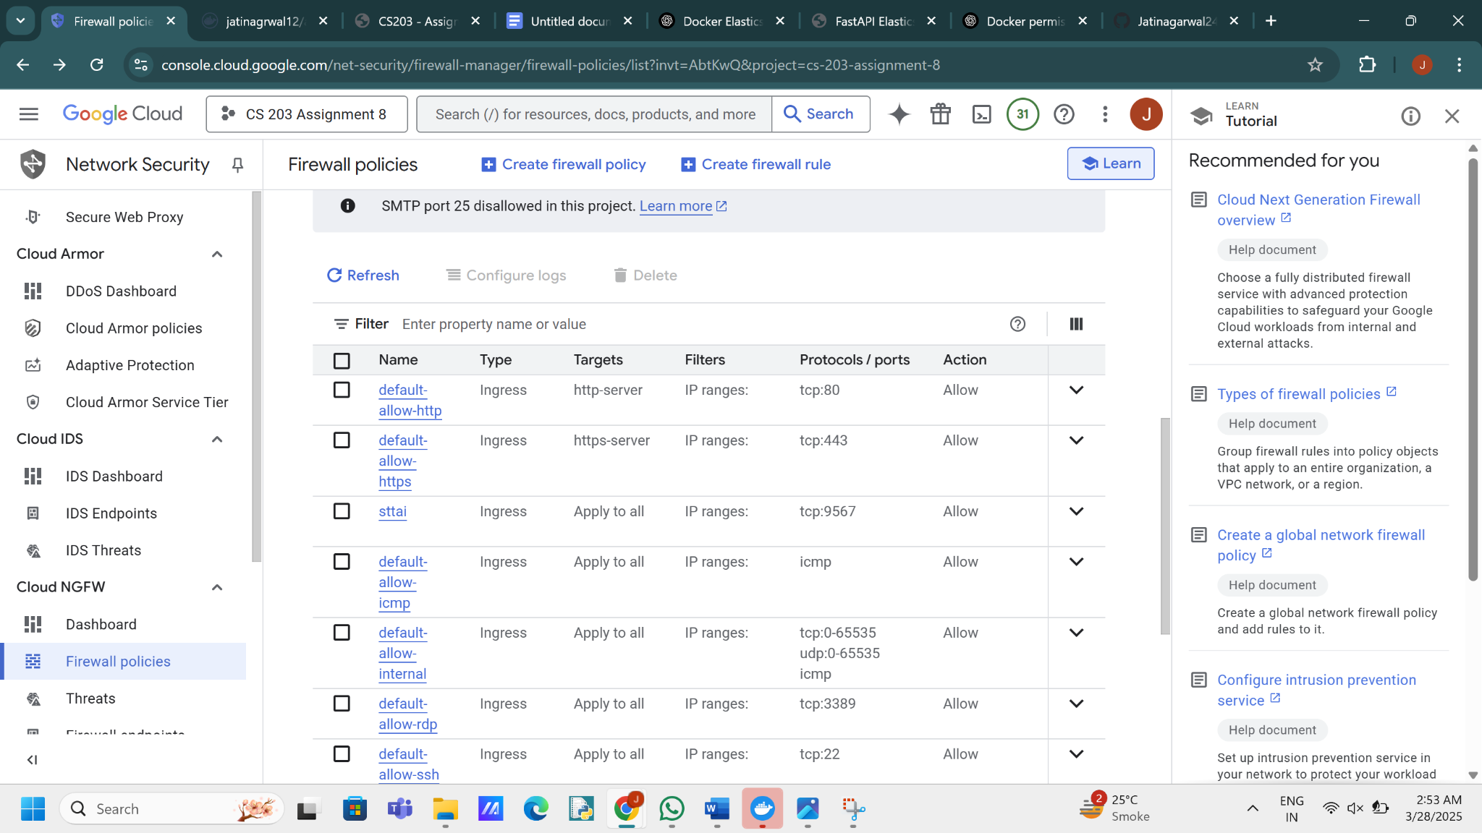

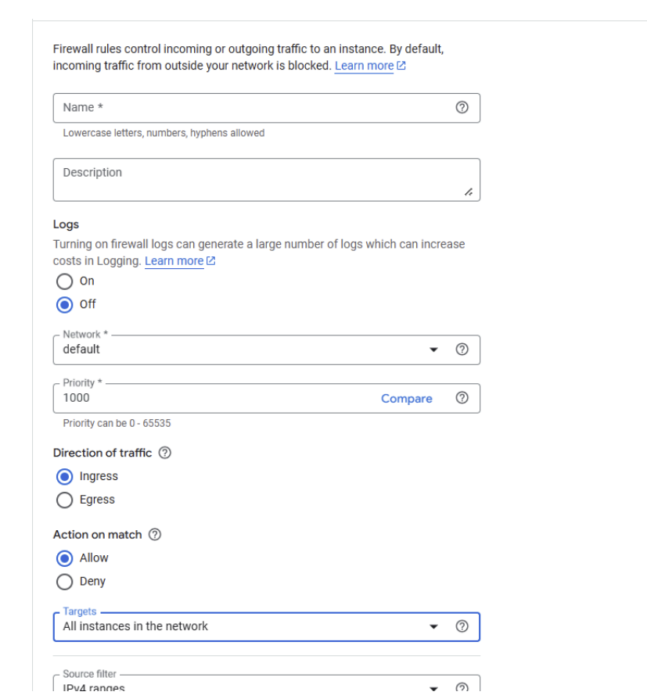

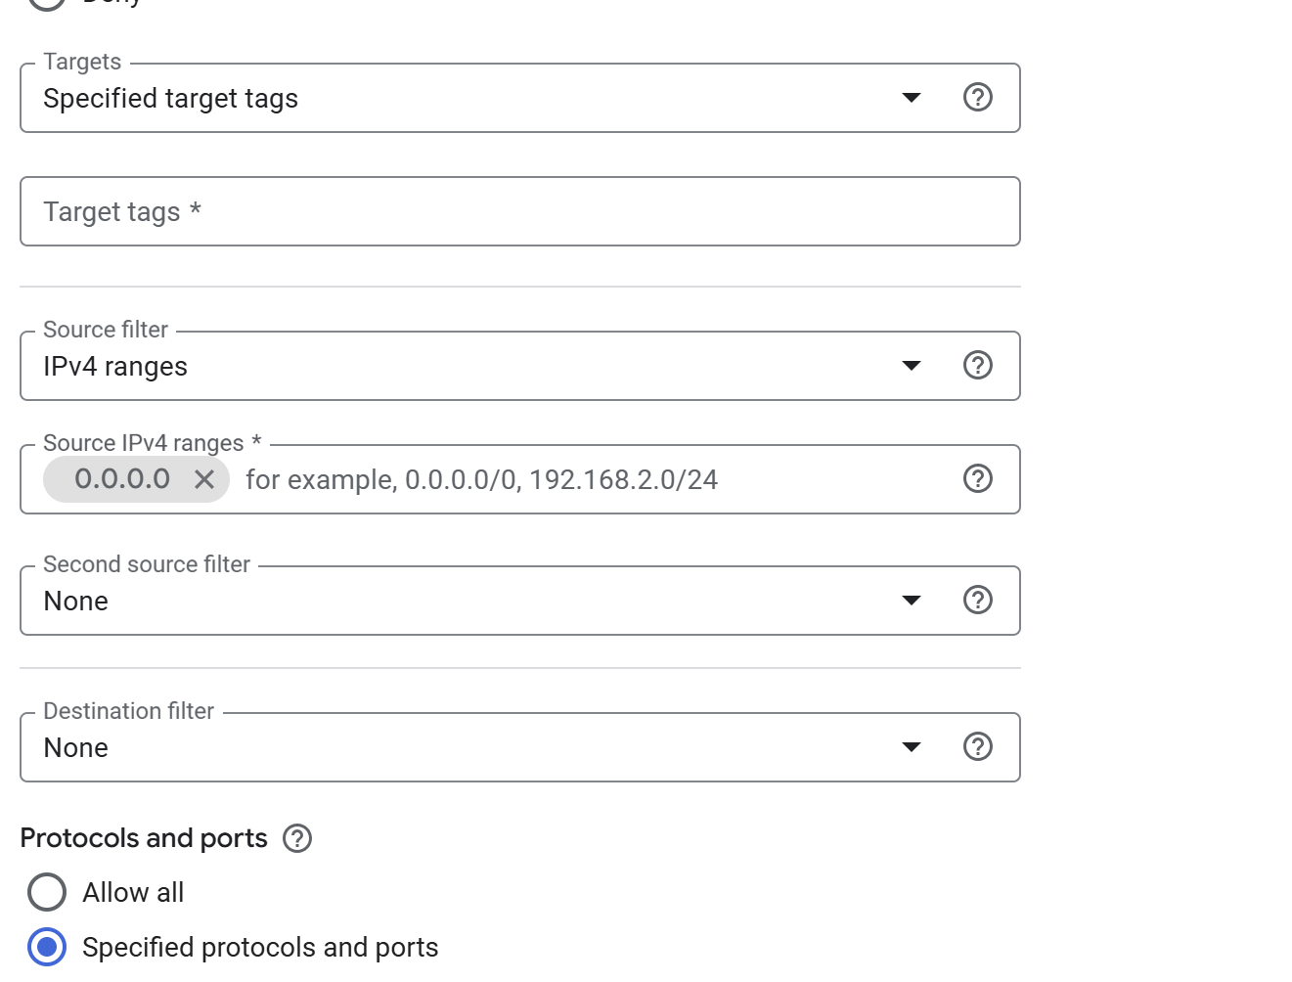

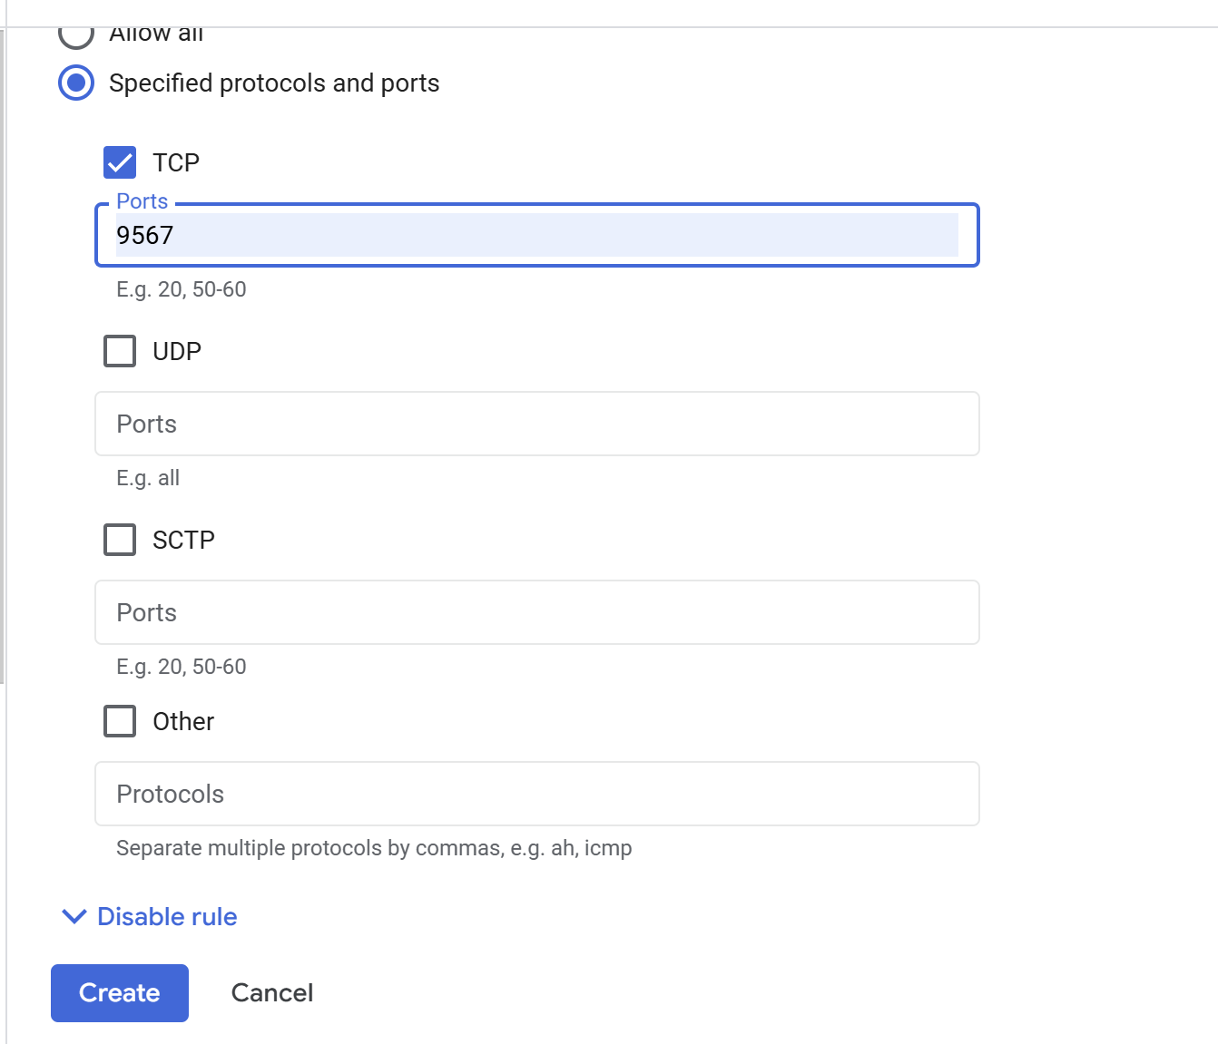

* Create a new firewall rule.
* Give any name and description. Keep the direction of traffic as ingress.
* In target types, apply to all instances.
* Check the TCP protocol, and write 9567 in the port.
* In the Source IPV4 ranges, give 0.0.0.0.
* Click Create.

Install Docker:

● Go to link: https://download.docker.com/linux/ubuntu/dists/noble/pool/stable/amd64/

● Download the last instances of all using wget command

● Run: sudo dpkg -i {package_name}

Make the frontend and backend instance:

● The codes for frontend and backend are available on the GitHub link provided.

Frontend DockerFile:

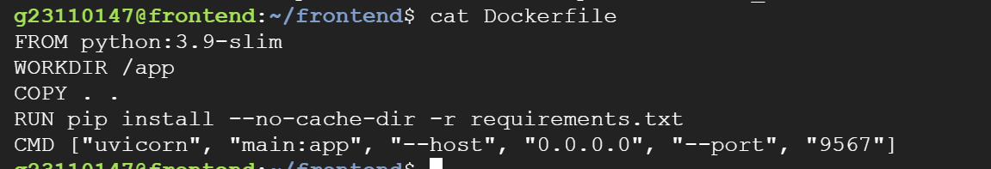

Building docker:

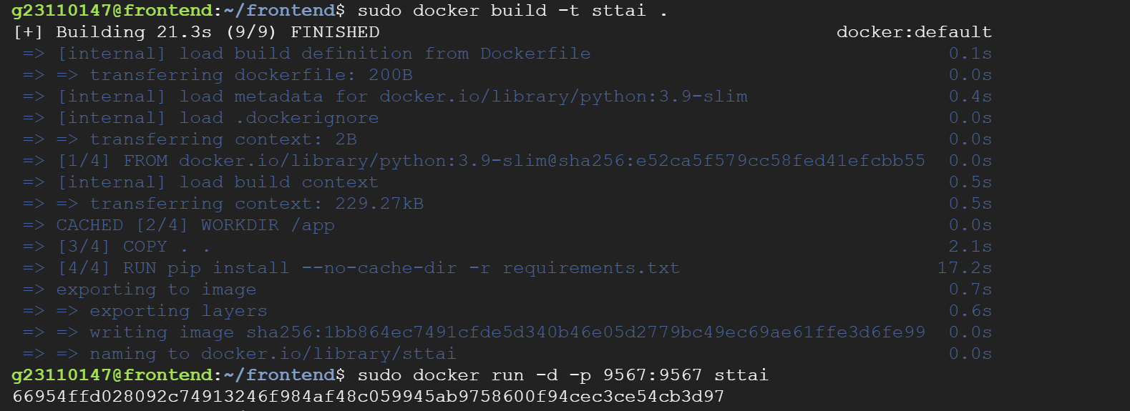

Running docker container:

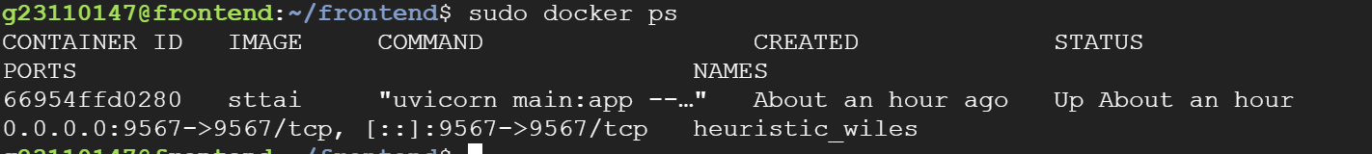

DockerFile Backend:

FROM python:3.9-slim

WORKDIR /app

COPY . .

RUN pip install --no-cache-dir fastapi[standard] elasticsearch requests

CMD ["uvicorn", "main:app", "--host", "0.0.0.0", "--port", "9567"]

docker-compose.yml:

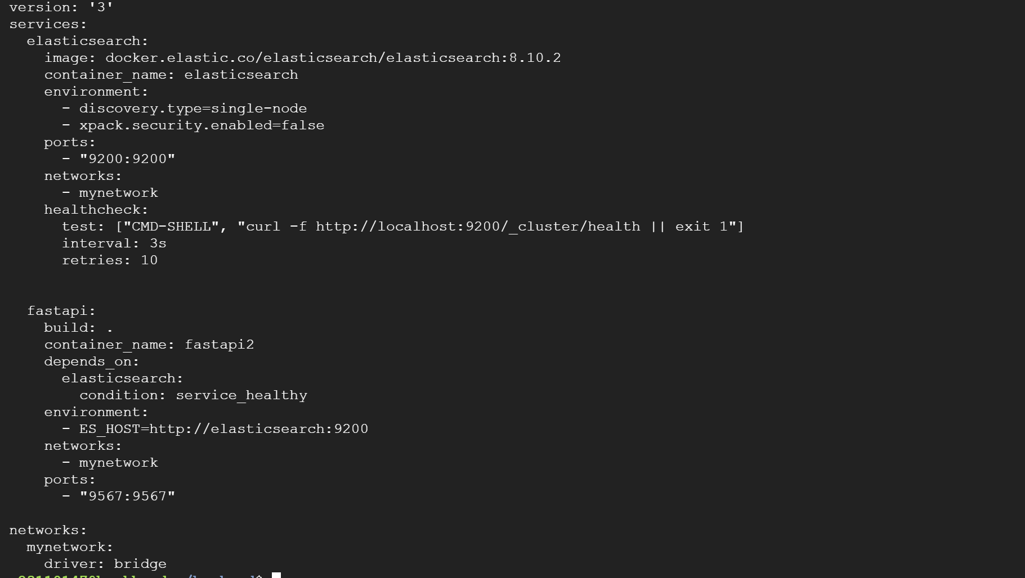

Running docker-compose.yml:

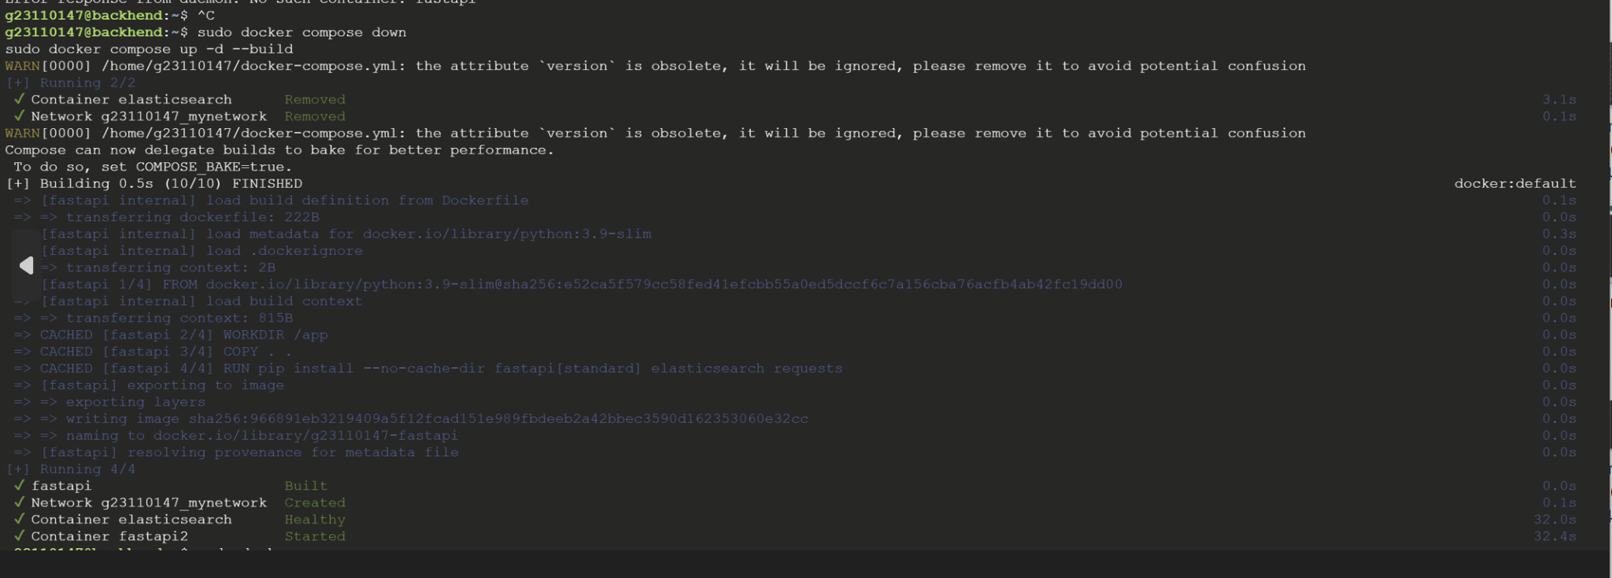



Website screenshot for get:

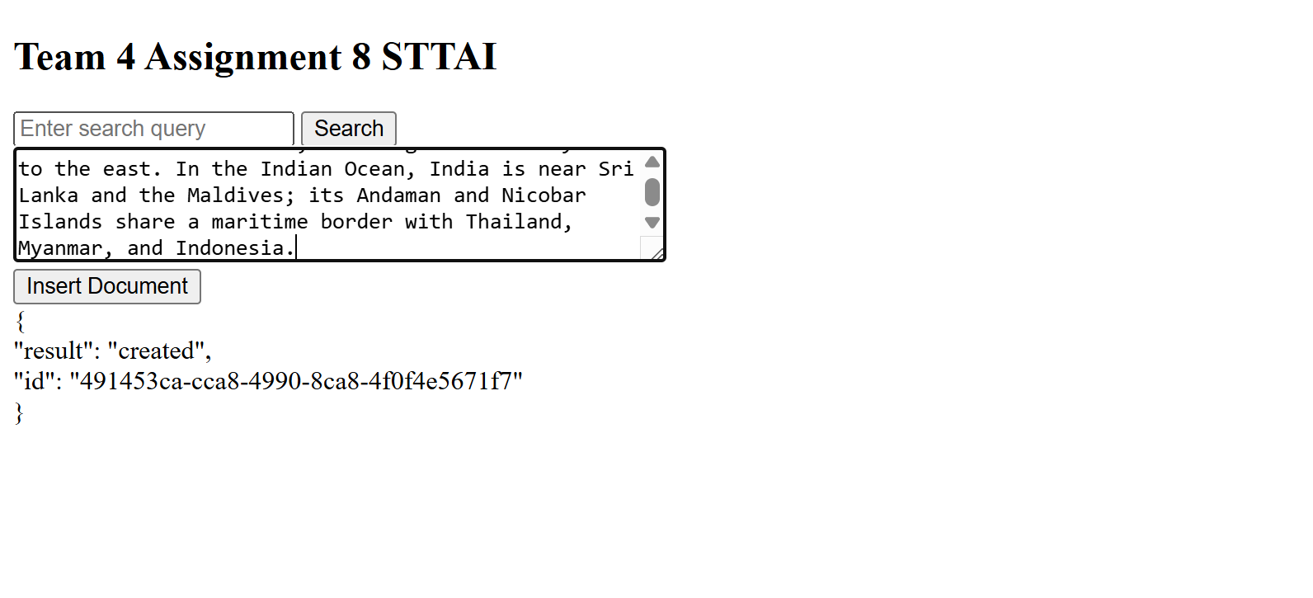

Website screenshot for insert:

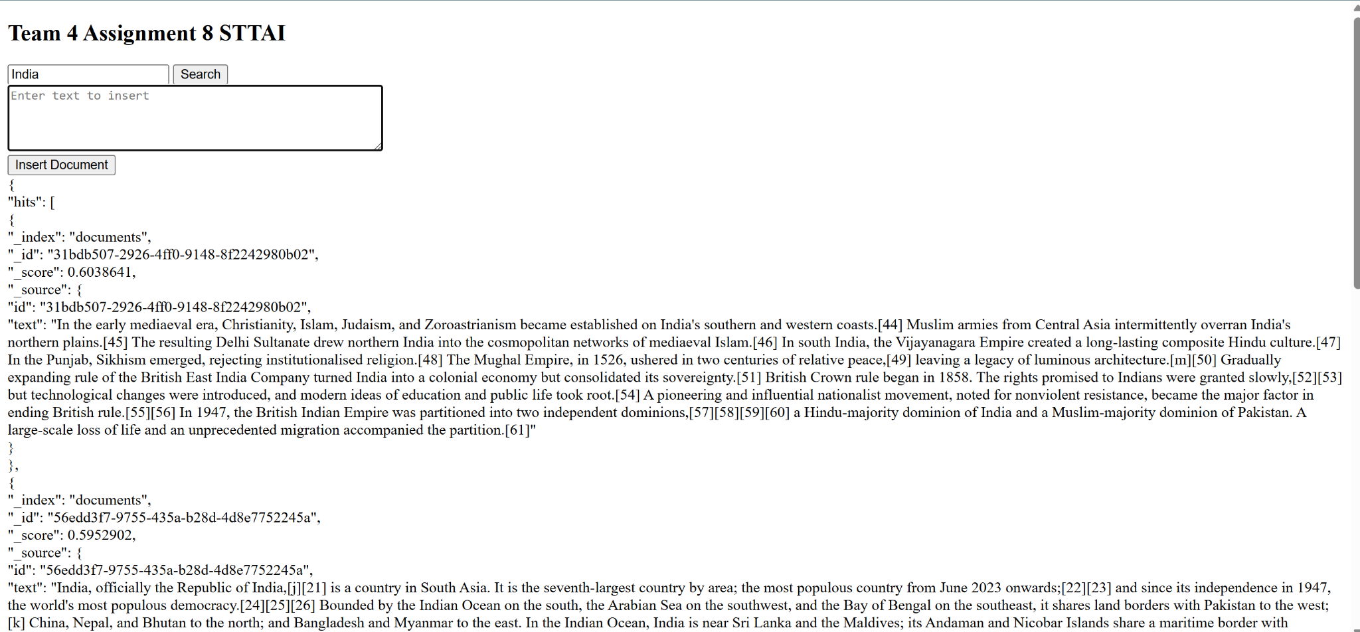

Screenshot for VM logs (insert):

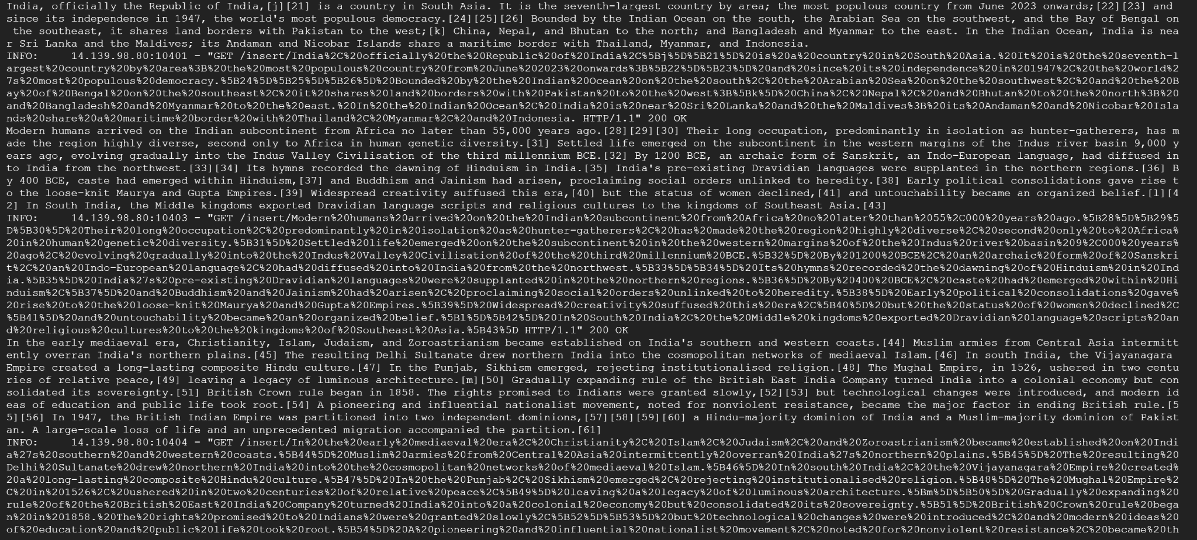

Screenshot for VM logs (get):



Docker inspect (frontend):

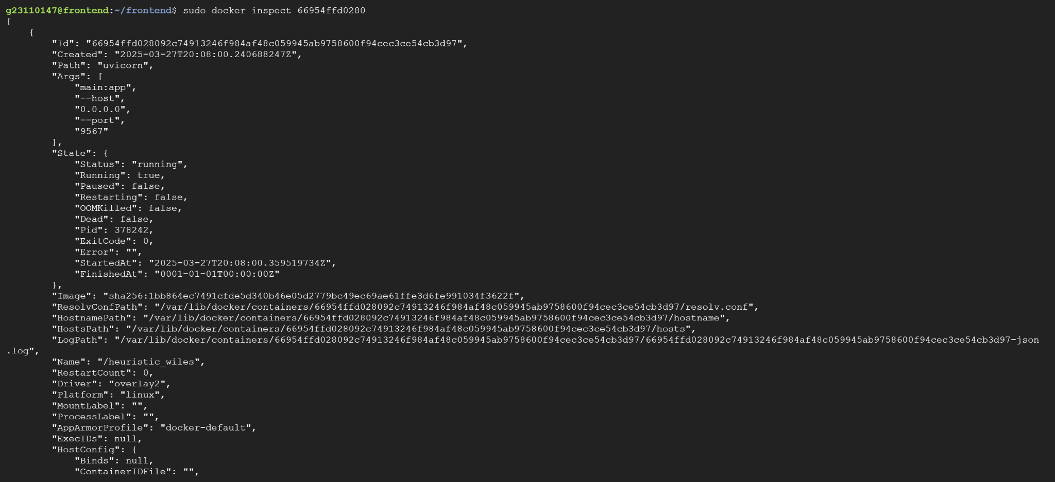

Docker inspect(backend):

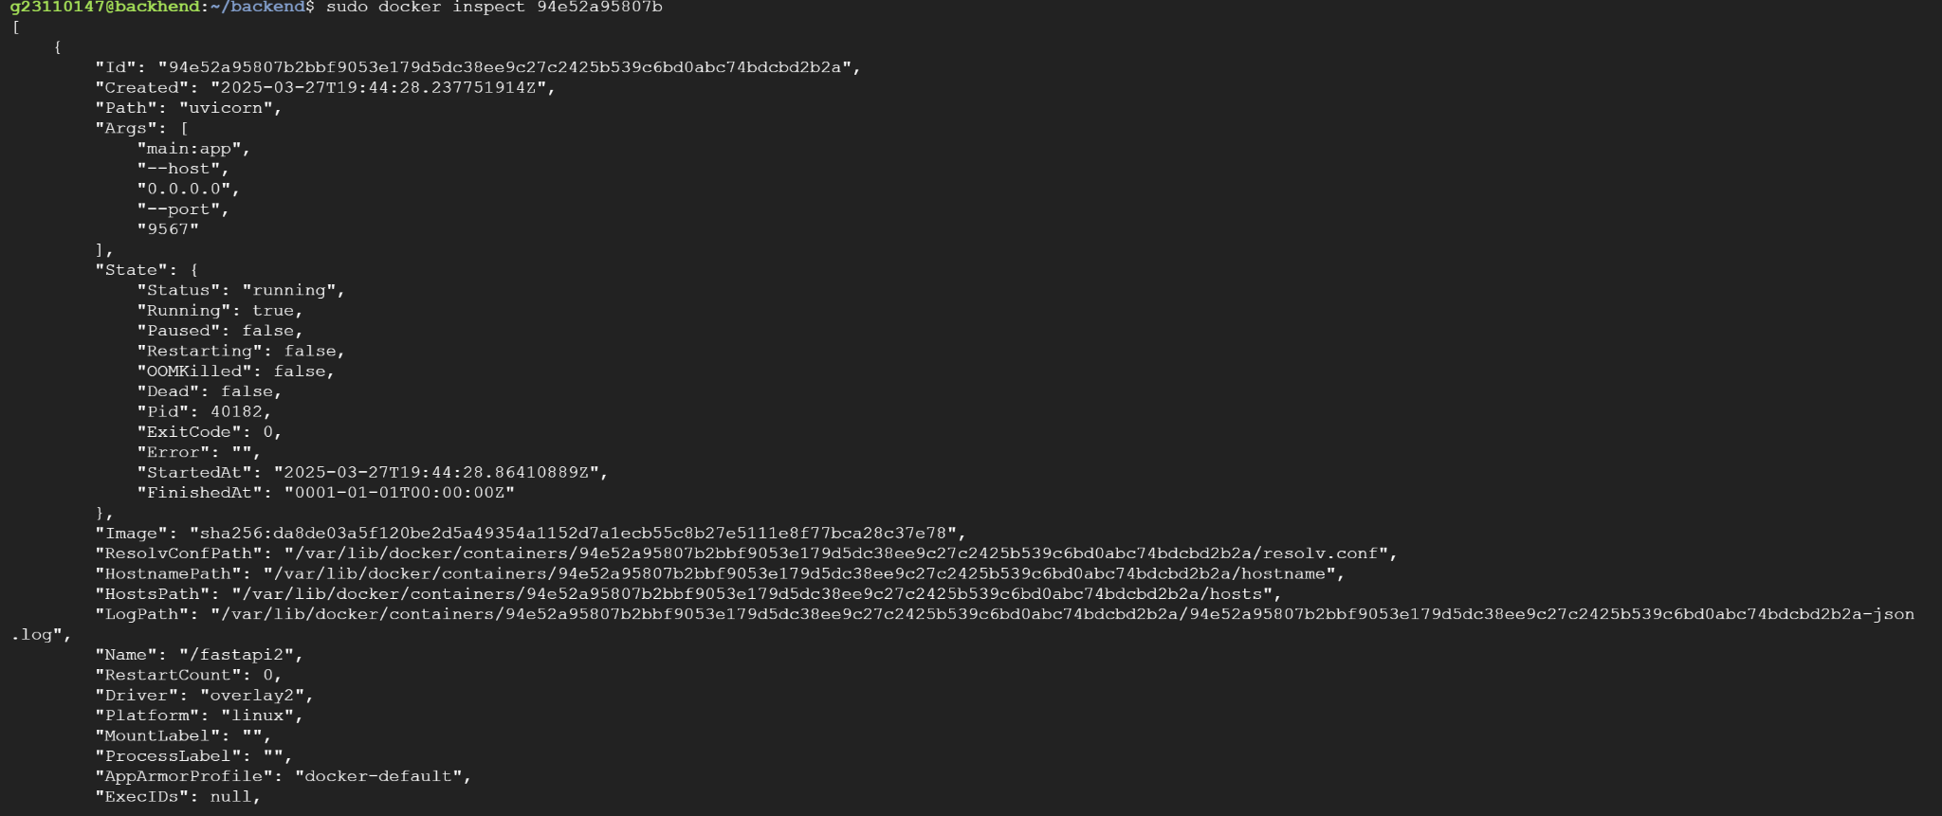

Docker inspect (backend):

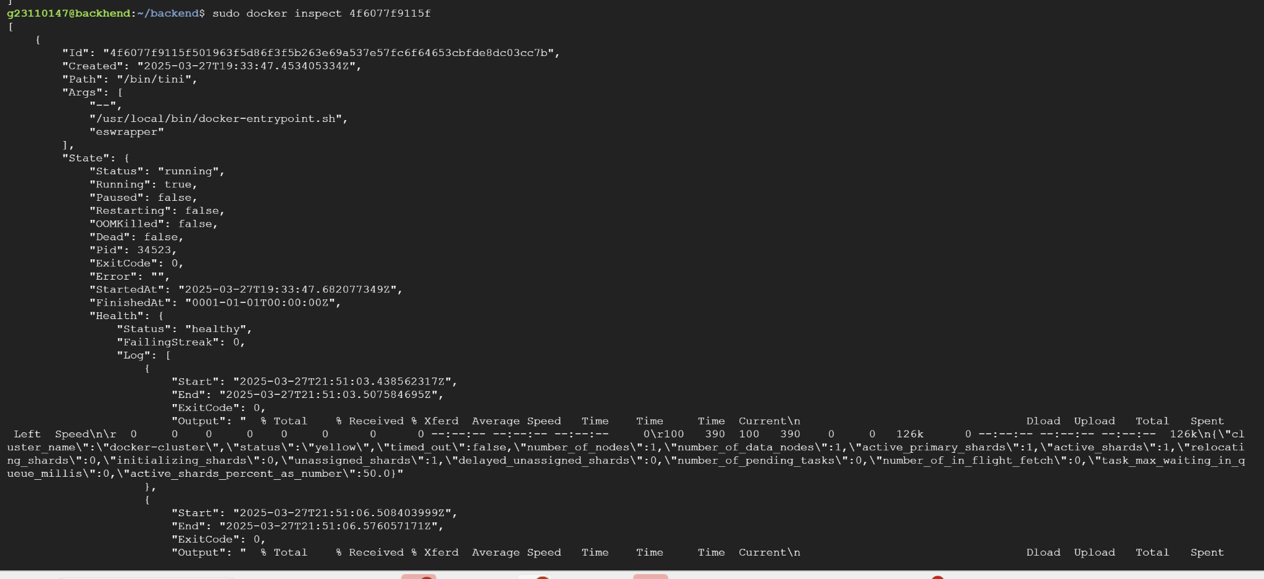

netstat -antp | grep LISTEN:

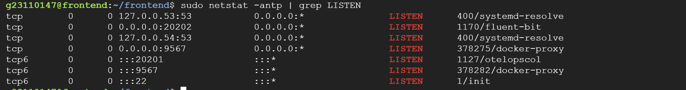

Docker Hub setup:

First we will login and then tag the image id and then push it in our repository

For fastapi-1

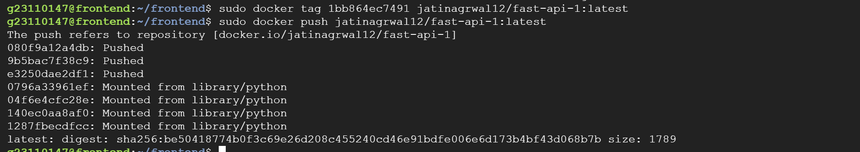





For elastic search



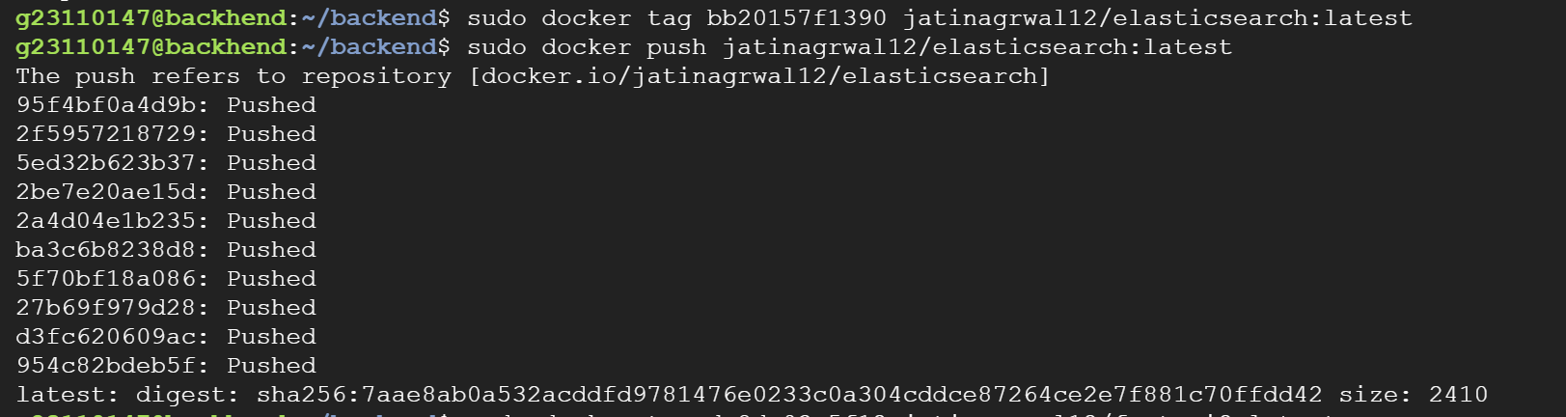

For fastapi-2



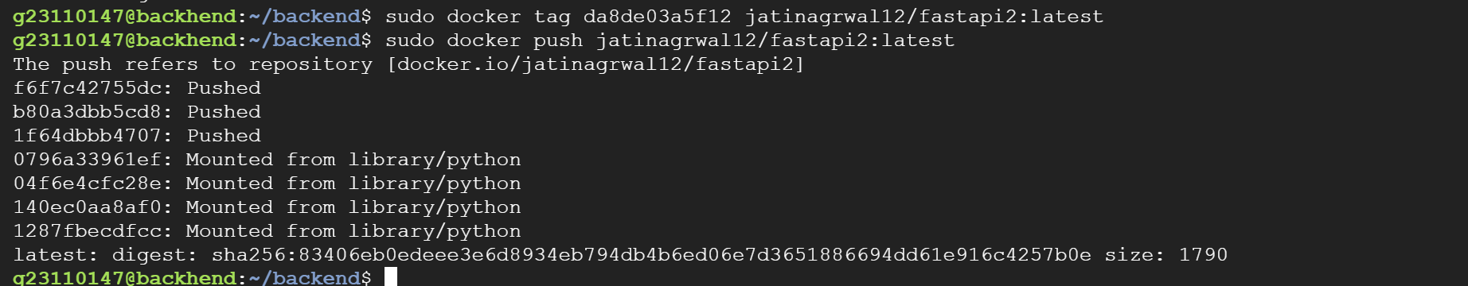

Architectural Diagram:

